ANALYTICS SPECIALIZATIONS & APPLICATIONS

Coursework 2: Brand Analytics Using Twitter

9th May 2025

Student ID: 20595117
Executive Summary:
In this analysis, we are tasked with creating an exploratory analysis of the public’s view of both Adidas and Lululemon, using a dataset of tweets from a 3-month period between October 1st, 2021 to January 1st, 2022. This time period provides the analysis with roughly 6,190 tweets containing ‘Lululemon’ in the body and 38,200 tweets containing ‘Adidas’ in the body.

In order to help the company see its position of the brand in the minds of its customers, this exploratory analysis will consist of a generally analysis of the tweets, a sentiment analysis, an analysis of the tweets’ creators, an engagement analysis, as well as more advanced analysis that includes core analytics and geospatial modeling. These models should help us understand the questions, who is engaging with these brands on twitter, what are they saying, and how are they feeling about the brands.
In order to achieve the results, the data was prepared and cleaned, and special care was taken with the body of text within each tweet, using clean text removal, to make the insights gained through analysis more actionable and meaningful. Next, a quick descriptive analysis was undertaken to get an initial insight into the raw data. Next, measures were taken to remove ‘spammy’ tweets and ‘bot’ activity that was detected through this initial analysis. It seems that there were many extremely active accounts that were tweeting similar (if not identical) content regarding the brands, especially Adidas, that would have to be removed in order to analyze sentiment accurately. After bots were dealt with, the analysis began looking at the most engaged tweets, mentions and word frequency, sentiment analysis, and geospatial analysis.
Adidas generated significantly more tweet volume than Lululemon, though much of it was tied to promotional activity like giveaways and highly duplicative content. After filtering, Lululemon showed a higher proportion of original, positive tweets (54.5% vs. 47.7% for Adidas). Sentiment spikes for Adidas aligned with major campaigns, while Lululemon maintained a more consistent tone. Geospatial analysis showed Adidas had broader global reach, but Lululemon's engagement was more organic and lifestyle-driven. These findings reflect distinct brand voices and audience behaviors on Twitter.
Approach Breakdown:
The first step was preparing the data for a basic descriptive analysis. A preliminary analysis on the raw data was performed in order to see what further steps would need to be taken to properly clean the data and prepare it for advanced analysis. This involved finding the total count, mean, median, min, and max values for all available columns within the dataset. Next, the data was cleaned. Missing values, which were only present in the ‘user.location’ column were filled with NA values. The location column took some special care to prepare for analysis, as it had many blank entries and ‘junk’ locations present. Many locations were not ‘real’ user locations (ex: ‘here’, ‘planet Earth’, ‘In the lab’) and were unusable. Some of the most common ‘junk’ entries were removed, and the rest were left as is; further cleaning was not necessary for the kind of geospatial analysis conducted. Next, the text was scrubbed using clean text removal, and the words were tokenized in order to set the body text up for further analysis, which is required for a smooth LDA and sentiment analysis. Stop-words, emojis, and common phrases that don’t actually mean much for our analytical purposes (ex: ‘https’, ‘rt’, ‘adidas’, ‘lululemon’) were excluded in order to achieve more meaningful insight during LDA and sentiment analysis. The original, full text column was kept as is, and a new column, cleaned text, was created for further use in our later analysis.

Then, a basic descriptive analysis was performed. Total tweets and total unique tweets were found by summing the total number of texts entries and finding the total number of entries that were not exact repeats of other entries. Top hashtags for each brand were found by analyzing the full text for any words preceded by a ‘#’ symbol.

During the preprocessing stage, a substantial number of duplicative tweets were identified, prompting further investigation into the presence of automated or spam-like activity within the dataset. To detect and mitigate this issue, the number of unique users and the frequency of tweets per user were examined, particularly focusing on those who posted over ten times. A targeted “high-frequency user analysis” was then conducted to assess whether heavily active accounts were legitimate contributors or likely bots. For Lululemon, high-volume users often expressed criticism or activism-driven sentiment, and their tweets were retained due to their relevance. In contrast, Adidas’s most prolific users were primarily promotional accounts posting repetitive content, some exceeding 100 tweets in the 90-day period. As a result, a filtered dataset was created by excluding users with more than 35 tweets, users who repeated the same tweet at least five times, and all retweets. This refinement removed approximately 26% of Lululemon tweets and nearly 50% of Adidas tweets, significantly improving the reliability of subsequent analyses.

Next, the secondary analysis was conducted. An engagement analysis was performed, and the most favorited and retweeted tweets were found. N-gram frequency was run to find words that were commonly strung together and to help understand what people were saying about the brands. Topic modeling was performed, but it did not lead to any significant or intelligible results, so it was left out of the analysis. A sentiment analysis was performed, and sentiment over time was found.

Geospatial analysis was done in the form of heatmaps. Both brands had enough location data to provide insightful worldwide heatmaps, but most of the data was concentrated in the United States. For this reason, both global heatmaps and United States state-level heatmaps were created.

The final step, in order to help find the best influencer to promote either brand, was a user analysis. The most active users, most engaged with users, and the users tweeting at either brand with the highest follower count were identified. Another final, user focused analysis was done which looked at only verified users with the highest rates of engagement.

Data Description Section:
The two companies chosen for analysis were Adidas and Lululemon. The tweets being analyzed range in date from the first of October 2021 to the first of January 2022. This provides us with a 3-month span of tweets from the end of the year, 2021. Adidas had many more mentions during this time period, with a total of 38,212 tweets while Lululemon had only 6,190 tweets directed at them. There was a total of 29,145 unique users who tweeted at Adidas, and 4,463 unique users who tweeted at Lululemon.

Adidas had many users (105) who tweeted at them more than 10 times, and some tweeted at them over 100 times. Lululemon had only 19 users’ tweet at them more than 10 times, and only 2 tweeted at them over 30 times. This was the first large discrepancy discovered in the data.

Another large discrepancy was discovered in the number of unique tweets for either brand. Lululemon had 4,834 unique tweets, meaning that 78% of the tweets directed at them were unique. Adidas on the other hand, had only 17,525 unique tweets, meaning that only 46% of the tweets directed to them were original. This likely means that Adidas has a lot more promotional content, spammy tweets, and ‘retweeted’ or ‘quoted’ content. These statistics will be analyzed more later.

Twitter Activity Summary: Lululemon vs. Adidas
Metric | Lululemon | Adidas
Total Tweets | 6,190 | 38,212
Unique Tweets | 4,834 | 17,525
Exact Duplicate Tweets | 978 | 15,910
Unique Users | 4,463 | 29,145
Users with >10 Tweets | 19 | 105

The data is from worldwide locations, the ‘user.location’ column seems to allow for free input as well since there were many ‘junk’ locations that seem to be free-handedly written. It should be noted though, that the vast majority of the tweets originated from the United States. This makes sense, as the US accounts for about 79% of Lululemon’s total revenue and about 25% of Adidas total revenue.

Analysis Section:
The following section explores key patterns in the cleaned Twitter data for both Adidas and Lululemon. It draws on a range of techniques including descriptive statistics, textual analysis, sentiment scoring, and geospatial mapping to understand brand-related conversations. The goal is to identify meaningful differences in how each brand is discussed, perceived, and engaged with online. Where relevant, results are supported by visualizations to highlight temporal trends, dominant topics, and geographic reach.

Temporal & Volume Trends
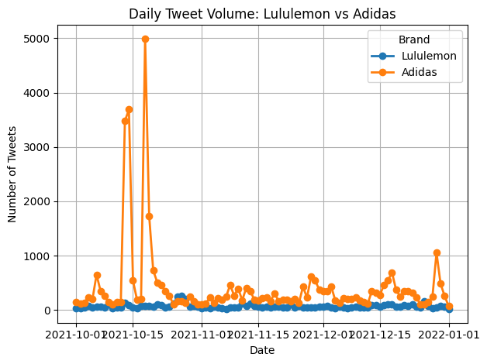
When examining tweet frequency over time, several distinct spikes in activity are evident. Identifying the causes behind these surges can offer valuable insight into the events or campaigns that drive user engagement with each brand.
To further investigate this volume phenomena, the most frequently used words during each spike period were analyzed, revealing clear links between volume increases and specific promotional or cultural moments.

Oct 12–22, 2021 | Nov 25–Dec 5, 2021 | Dec 25–Jan 1, 2022
xbox | boredapeyc | impossibleisnothing
austinekeler | weareivypark | donovanmitchell
xboxsweepstakes | internship | inspire
win | program | generation

The spike starting on October 12th was caused almost entirely by and Adidas sponsored Xbox giveaway which was promoted through adidas sponsored American Football Player Austin Ekeler. The November 25th spike can be attributed to multiple things. Adidas revealed a new NFT project with Bored Ape, their partner brand Ivy Park had a new release, and Adidas internship program was being promoted by the company. The final spike I in the dataset was also caused by multiple factors, but was led by the relaunching of their ‘Impossible is Nothing’ campaign during the release of their 2021 annual report. Additionally, Adidas sponsored athlete Donavan Mitchell released a new shoe design.

Analyzing these temporal trends allow Adidas, to understand what drives engagement. During the three-month period, Adidas achieved over 100 times their normal twitter mentions during these spike periods due to promotions, new partnerships, and new campaigns. Sponsored athletes really helped drive this content. Adidas should digest this information and understand that in order to drive engagement, they need to leverage their athlete sponsorships and focus on ‘keeping things fresh’ by heavily promoting new releases through social media, and to not be afraid of continuing their efforts with giveaways and sweepstakes.

Textual Content & Brand Language
Understanding the most frequently used hashtags offers valuable insight into the online communities and narratives that shape brand perception. Hashtags serve as a lens into what customers care about, how they engage with brand messaging, and which campaigns or issues are resonating. By analyzing these patterns, brands can better align their communication strategies with user sentiment, tailor content to active communities, and identify opportunities for more authentic engagement. This is particularly important in distinguishing between organic brand advocacy and externally driven promotional traffic.

Top 10 Hashtags by Brand
Lululemon | Count | Adidas | Count
#thesweatlife | 113 | #xboxsweepstakes | 7147
#lululemoncoalprit | 71 | #impossibleisnothing | 1168
#12daysofcheckout | 68 | #adidas | 694
#fossilfreefashion | 65 | #xbox20 | 482
#lululemon | 64 | #giveaway | 410
#coalsweats | 61 | #running | 405
#teamcanada | 44 | #runningshoes | 399
#yoga | 33 | #nft | 178
#fitness | 19 | #boltup | 169
#beijing2022 | 18 | #metaverse | 163

The above table displays the top hashtags for each brand. Hashtags are twitter users’ way of posting into communities, and Adidas and Lululemon could both benefit by understanding how its customers identify with one another.

Lululemon’s top hashtags are very focused, and brand centered, ‘#thesweatlife’ ‘#lululemon’ ‘#yoga’ and ‘#fitness.’ These are all words that Lululemon pushes and communities it has branded internally. It’s other two top categories of hashtags are marketing campaigns like ‘#12daysofcheckout’ and ‘#beijing2022’ and activists’ posts attacking Lululemon for their use of coal and other fossil fuels.

Adidas, on the other hand, is mostly trending due to their xbox giveaway promotion. The communities with active hashtags unrelated to xbox are ‘#running’, ‘#runningshoes’, and ‘#boltup.’

Coupling the most used hashtags for each brand, as well as looking at the most frequent words contained in tweets, will provide insight into the online communities surrounding the brand and what they are saying about the brand.

N-gram Frequency
Initially, word clouds were created, but looking at single words out of context did not provide impactful insight. To remedy this, we ran an N-gram frequency analysis to find the most common words strung together in groups of 2 and 3.

Top 2-grams
Lululemon | Adidas
customer service | austinekeler adidas
renewable energy | adidas xbox
team canada | chance win
Looks like | exclusive kit
yoga pants | win exclusive

Top 3-grams
Lululemon | Adidas
ditch coal renewable | austinekeler adidas adidasfballus
hockeynight teamcanada lululemon | chance win exclusive
yoga pants factories | xboxsweepstakes chance win
lululemon best looks | win exclusive kit
best looks like | exclusive kit including
making yoga pants | adidas xbox follow
lululemon practicing preaches | xbox follow rt
practicing preaches making | follow rt xboxsweepstakes
preaches making yoga | rt xboxsweepstakes chance

The n-gram analysis reinforces broader patterns seen throughout the dataset. Adidas-related tweets are dominated by promotional language tied to sweepstakes, giveaways, and sponsored athletes, with repeated phrases such as “xboxsweepstakes,” “win exclusive kit,” and “austinekeler adidas.” This indicates that Adidas's Twitter engagement during the observed period was heavily driven by campaign activity rather than organic conversation. In contrast, Lululemon’s most common bigrams and trigrams center around product attributes and values — including “customer service,” “renewable energy,” “yoga pants,” and “team canada.” These results suggest that conversations around Lululemon are more grassroots in nature, focused on product experience, corporate responsibility, and partnerships. Overall, the n-grams highlight a key distinction: Adidas’s presence is event-driven and attention-seeking, while Lululemon’s is rooted in sustained brand identity and consumer trust.
Sentiment & Perception
Brand | Positive | Neutral | Negative
Lululemon | 54.54% | 32.65% | 12.81%
Adidas | 47.66% | 42.90% | 9.44%

As we can see, the brand’s perception was overwhelmingly positive or neutral. Based on previous discovery, the bulk of Lululemon’s negative publicity is due to activists fighting against their use of coal and fossil fuels. Luluemon has a higher negative sentiment because of this, but their positive score is significantly higher than Adidas.

To see a more nuanced view on sentiment, daily average sentiment over time was investigated.

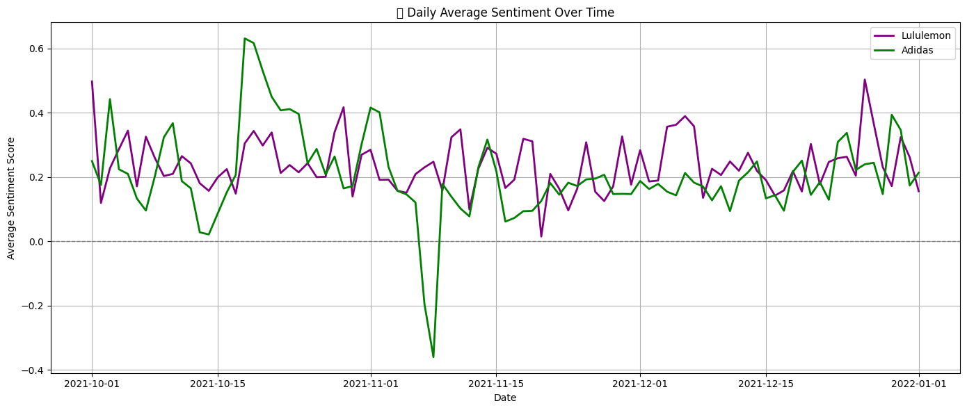
Daily Average Sentiment Over Time

There are some interesting trends to be gleaned from daily average sentiment over time. Mainly, we see that most tweets are positive, and they rarely are negative on average in a day – except for in special circumstances. We see that in the middle of November, there was a large negative sentiment for Adidas over a few days’ period. It is obvious why this spike occurred when the tweets from that period are read. During that time period, Adidas sponsored athlete, Aaron Rodgers, went on a popular forum and came out as anti-vax. After this, for about a week, there was media uproar and people were calling for Adidas to step up and drop him as a sponsor with people calling him a ‘#fraud’, ‘bad guy’, and an ‘#assclown’ in their tweets.

The large positive spike in Adidas sentiment, which can be observed in mid-October, is from their xbox giveaway with Adidas sponsored athlete Austin Ekeler. Adidas and Lululemon should note that brand influencer causes the largest swings in sentiment. For better or for worse, brand influencers bring masses of attention to their sponsored brands.

Geospatial Analysis
In order to figure out where users were interacting with the brands from, a geospatial analysis was performed. An initial descriptive analysis, it was apparent that most of the tweets originated from the US, though both countries still have international reach. In order to get a full picture, a geospatial analysis was performed on a statewide, inter-US scale and a global Country scaled measure of volume of tweets during the period.

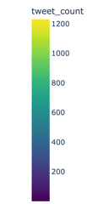
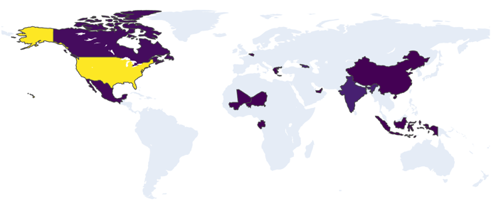
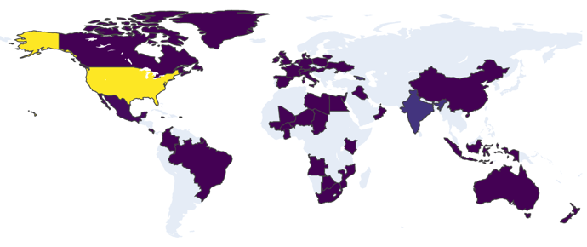
Adidas Tweet Volume by Country Lululemon Tweet Volume by Country

The country-scale data shows that a severe majority of the users are from the United States, followed not so closely by India for both brands. We can see though, that Adidas has a vast global following, whereas Lululemon is more heavily concentrated in the Americas and Asia.
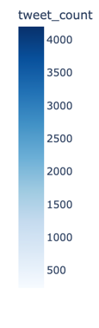
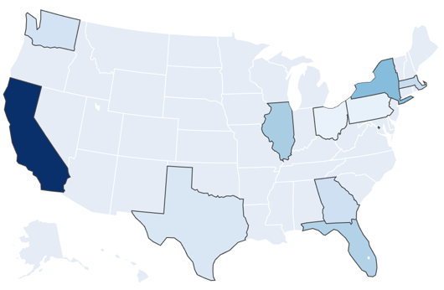
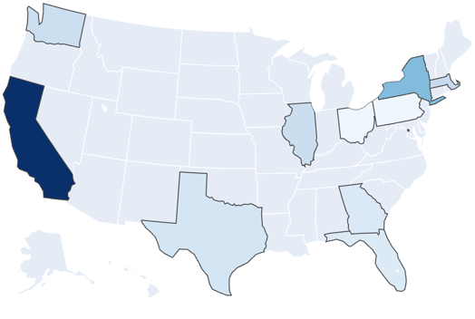
Adidas Tweet Volume by US State Lululemon Tweet Volume by US State

In the state-scale data, California holds the heavy majority of tweets about either brand, but it can be noted that the wealthiest and most densely populated states are the ones tweeting about Lululemon. This says a lot about the community surrounding Lululemon, and potentially provides marketing and advertising insight for the company.

Micro- Influencer Recommendation:

User Analysis
To identify effective micro-influencer candidates for each brand, user-level engagement data was analyzed across multiple dimensions: tweet frequency, total retweets and likes, follower count, and verification status. Verified users with high engagement and authentic, brand-relevant commentary were prioritized. This approach ensured that bots and inorganic activity were excluded, highlighting users with an existing, loyal audience and genuine enthusiasm for the brand.

For Adidas, the recommended candidate is Stein, a verified gaming personality known online as @steinkin. With over 40,000 followers and consistently high-performing tweets—often exceeding 25,000 combined likes and retweets—Stein frequently engages with Adidas content, particularly their footwear. His organic enthusiasm, coupled with his influence in the online gaming space, positions him as a highly relevant and cost-effective micro-influencer for the brand.

For Lululemon, the ideal candidate is Ryan Clark, a former professional athlete and verified Twitter user with a following of over 265,000. Despite no formal affiliation, Clark has tweeted positively about Lululemon on multiple occasions, praising their product line. His unsolicited advocacy, credibility as a former NFL player, and large audience make him a strong strategic partner for targeted brand engagement.

Conclusion:
This research aimed to evaluate public discourse and brand perception surrounding Adidas and Lululemon through Twitter-based textual analysis. Using a combination of data cleaning, natural language processing, sentiment analysis, and topic modeling on over 44,000 tweets, we filtered out promotional noise to focus on original consumer content. The study found that Lululemon tweets were more consistently positive, while Adidas experienced large, engagement-driven spikes tied to promotional campaigns such as giveaways. Geospatial and temporal analyses revealed Adidas’ broader reach, but also a higher concentration of retweets and duplicated content. Topic modeling further suggested that Lululemon’s conversation centered on lifestyle and well-being, whereas Adidas was associated more with events and influencer partnerships. These findings support the use of social listening to monitor brand perception and identify effective engagement strategies. Future studies could expand the timeframe and include more platforms to deepen cross-brand insights.

MarketWatch. (2024, March 21). Lululemon’s stock keeps falling, but one analyst says the market is wrong. Retrieved from https://www.marketwatch.com/story/lululemons-stock-keeps-falling-but-one-analyst-says-the-market-is-wrong-7d0309aa
Adidas AG. (2024). North America – adidas Annual Report 2023. Retrieved from https://report.adidas-group.com/2023/en/group-management-report-financial-review/business-performance-by-segment/north-america.html

